To: | All Stakeholders | From: | Glen Wiczorek
 |  |  | City of Ann Arbor
File: |  | Date: | February 10, 2021

Reference: Call to Artists
Ann Arbor WTP Stairwell Mural

Call to Artists
2021 Ann Arbor WTP Stairwell Mural
in connection with the Ann Arbor Art Commission

*Due to the impact of COVID-19, all timelines and budgets for this project are subject to change. These changes will be determined by the City of Ann Arbor. Staff will communicate any changes or delays to applicants as the information becomes available. All efforts are being made to continue supporting creative expression and artists. We thank you for your understanding and patience as we navigate these challenging times.

SUMMARY: The City of Ann Arbor is seeking an artist(s) to create and complete a painted mural in the stairwell of the Ann Arbor WTP Administration Building. The stairwell is approximately __’x__’x__’ high. The award will be for $17,000. Work shall be completed by March 2022 or earlier. First application deadline is July 1, 2021 May 15, 2021.

INTRODUCTION:
Ann Arbor’s Drinking Water Treatment Plant (WTP) was originally constructed in 1938 and has undergone numerous expansions and improvements in the 1940s, 1960s, 1970s, 1990s and 2000+. The WTP primary source of raw water (approximately 80%) is from the Huron River which is impounded by the Barton Dam originally constructed in 1912. The remaining 20% of the raw water comes from ground water wells. The two raw water sources are blended and treated at the WTP located at 919 Sunset Road, Ann Arbor, MI 48103 and then delivered to the City’s 125,000 customers.

The AA WTP is very proactive with transparent communication and public engagement. Examples of the City’s communication with customers can be viewed at www.QualityWaterMatters.org. This url leads to the City’s drinking water website and includes copies of the City’s monthly water report to customers. You will also find the City’s branding and logo at this location. Part of the City’s public engagement approach is to conduct a water plant open house each year in May, where hundreds of patrons attend. Additionally, the WTP provides tours to schools throughout southeast Michigan. The tours highlight the history of the WTP, its raw water sources, its treatment processes and our commitment to delivering safe drinking water exceeding all regulatory requirements. Over the course of a year, more than 2000 community members visit the City’s water treatment plant.

The stairwell in the Administration Building is highly visible to public visitors in two ways:
- The stairwell is used by public visitors to access the second floor of the water plant where the Environmental Lab is located for testing of water samples and other support.
- The stairwell is situated at the beginning of all water treatment plant tours.

The stairwell resides in a highly trafficked location in the water plant and will serve as a dramatic space for the proposed mural.

ABOUT ANN ARBOR:
The Ann Arbor Art Commission is dedicated to furthering an emerging arts scene in our increasingly diverse population. We believe that art connects, heals, inspires, teaches, and speaks to us in myriad ways that build stronger and more vibrant communities. Public art gives our community a collective voice and a way to express our values while it brings awareness of and beauty to both the physical and cultural landscape of our city.

ELIGIBILITY
The competition is open to all artists or designers, individually or as teams.

SCOPE OF WORK:
The artist(s) will design and create a work of art in the stairwell of the WTP Administration Building. While the mural is not required to cover all four walls, the mural design should be maximized to take advantage of the dramatic __’ high space on as many walls as possible. If the mural design does not cover all four walls in its entirety, any remaining wall surface not included in the design should be finish painted as part of the artist’s scope of work.

The stairwell is constructed of painted concrete masonry units with mortar joints for three walls, and painted wall board for the fourth wall. The artist may elect to skim coat the surface to minimize the impact of mortar joints, however this will be at their expense and included as part of the grant funding. The existing block walls are primed and painted.

The stairwell can be closed during the painting of the mural. Artist(s) shall be responsible for all painting and necessary materials and equipment including scaffolding, fall restraint and other safety measures.

PROJECT GOALS:
The mural will be serving a specific purpose and therefore the WTP has specific goals and objectives associated with it. The stairwell is used by public accessing the second floor of the WTP, and is used on all public tours throughout the year. As such, it is envisioned that the mural could depict the long history of the WTP and/or serve as an educational component on the tours. Themes for the work of art should include one or a combination of the following concepts, in no particular order:

- Concept 1: Incorporate educational concepts directly tied to drinking water treatment. Concepts that could be addressed include:
  - The Huron River Watershed and source water protection
  - Water softening
  - Disinfection
  - Filtration
The City would be happy to meet with any prospective artist to discuss these technical processes in more detail.

- Concept 2: Reflect the long history of the WTP and its origins dating back to the original construction during the art deco era of the 1930’s. The vision of this concept is to serve as an homage to the hard working laborers who originally constructed the plant and dams, and at the same time also honoring the work force who continue to operate and maintain the plant today. The concept would hopefully capture the strength, dedication and teamwork of the work force that served (and serves) as the foundation of our commitment to safe drinking water. Two examples below were both coincidentally painted during the same era that the AA WTP was originally constructed.
  - Example: Construction of the Dam; William Gropper; 1938; Smithsonian American Art Museum
  - Example: Detroit Industry; Diego Rivera; 1933; Detroit Institute of Arts
Note: The City has an extensive collection of original photos depicting construction of water-related infrastructure. Please contact the City if you wish to review materials.

- Concept 3: The third concept is more open-ended. It is intended to encourage the artist’s own creativity while still attempting to support the educational component, the commitment to safe drinking water, and the critical role that the WTP plays.

Spatially, it is the City’s goal to maximize the surfaces provided by the stairwell. The stairwell serves as a dramatic canvas with ceilings rising __’ above the floor. While the stairwell is enclosed by four walls, it is not required that all four walls be used for the mural. Never the less, the City wishes at a minimum to focus on the more dramatic surfaces receiving the best vantage points. Should the artist not use portions of the stairwell for their mural, the remaining surfaces shall be finish painted in a color scheme complementary of their final design.

SCHEDULE AND SEQUENCE:
The selection process shall be a two stage effort. All dates are approximate, subject to change and are presented for guidance only.

Stage 1
- The first stage calls for the initial applications to be due May 15, 2021. Application details are found later in the Call to Artists.
- The initial applications shall be evaluated by a Review Committee established by the City and comprised of City and WTP staff, representatives of the local public art community, a representative of the Art Commission, and other designees.
- Announcement of short listed artists will be approximately July 1, 2021.

Stage 2
- The second stage shall have the short listed artists be given a stipend of $250 each to further their concept and submit final renderings for City selection.
- Renderings are due August 31, 2021.
- Interviews may be conducted during the month of September 2021.
- From the short listed artists, the City WTP will award the project to one finalist in early October 2021.
- The artist shall have approximately four to six months to complete the final design and the finished painting of the mural. Completion date is approximately March 2022 or earlier.

BUDGET:
As described above, the selection process is a two stage effort. After short listed artists are selected, each artist shall receive a stipend of $250 to further their conceptual ideas and submit a final rendering to the City. A finalist shall be selected based upon the renderings.

The award to the final artist for the complete project is $17,000 and is inclusive of ALL artist’s costs, including but not limited to artist fees, supplies, and materials, equipment, insurance, studio costs, assistant fees/production support, technical, travel and lodging, time for municipal review and approval, and all other costs related to the design and production of the work of art.

APPLICATION:
Please send all items in one email; send images and mural design template as .jpeg or .png files. Partial applications or ineligible applicants will not be considered. Present your materials in the following order:

Stage 1 – Initial Application
- Professional resume (2-pages maximum): Teams must submit a short resume for each member.
- Include two to three references: Client name, contact name, and phone number.
- Examples of previous murals: Each file must be annotated with the artist’s name, title (if applicable) location of work, medium, date of work, and dimensions. Indicate budget where applicable.
- Written Proposal (Typed): describe overall design concept, style of art to be designed (with sample images), and any relevant information that affects the design and/or concept development. (i.e. explain your design and how you relate to WTP concepts and visions.)
- Visual Support: includes conceptual design sketch(es), color palettes, and locations (i.e. how many walls) which reflects the overall design concept and style.
- Fabrication & Installation: Explain your proposed schedule, process, and medium. Describe the anticipated fabrication and installation needs for the permanent art and maintenance requirements if applicable. Paint materials shall be washable. Be sure to include information that will help facilitate the artistic integrity and knowledge about appropriate material’s sealer. Describe special equipment or other needs which would need to be approved pre-installation.

Stage 2 – Short listed Artists
- Short listed artists shall receive a stipend of $250/each.
- Short listed artists shall further their conceptual design sketches and color palettes from the initial application.
- Short listed artists shall submit final renderings and color palettes for the mural, with spatial considerations.

Finalist
- Finalists shall incorporate City comments, complete their design and present to the City.
- Finalists must provide appropriate policies and detailed explanation of insurance and liability coverage during installation.
- Finalist shall be required to sign the City’s contract.

APPLICATION EMAIL:
Please send all correspondence to: Water@a2gov.org by 11:59pm on July 1, 2021 May 15, 2021.

SITE AND PROJECT DETAILS:
See images below

Photo 1: View of Stairwell from top floor landing looking south
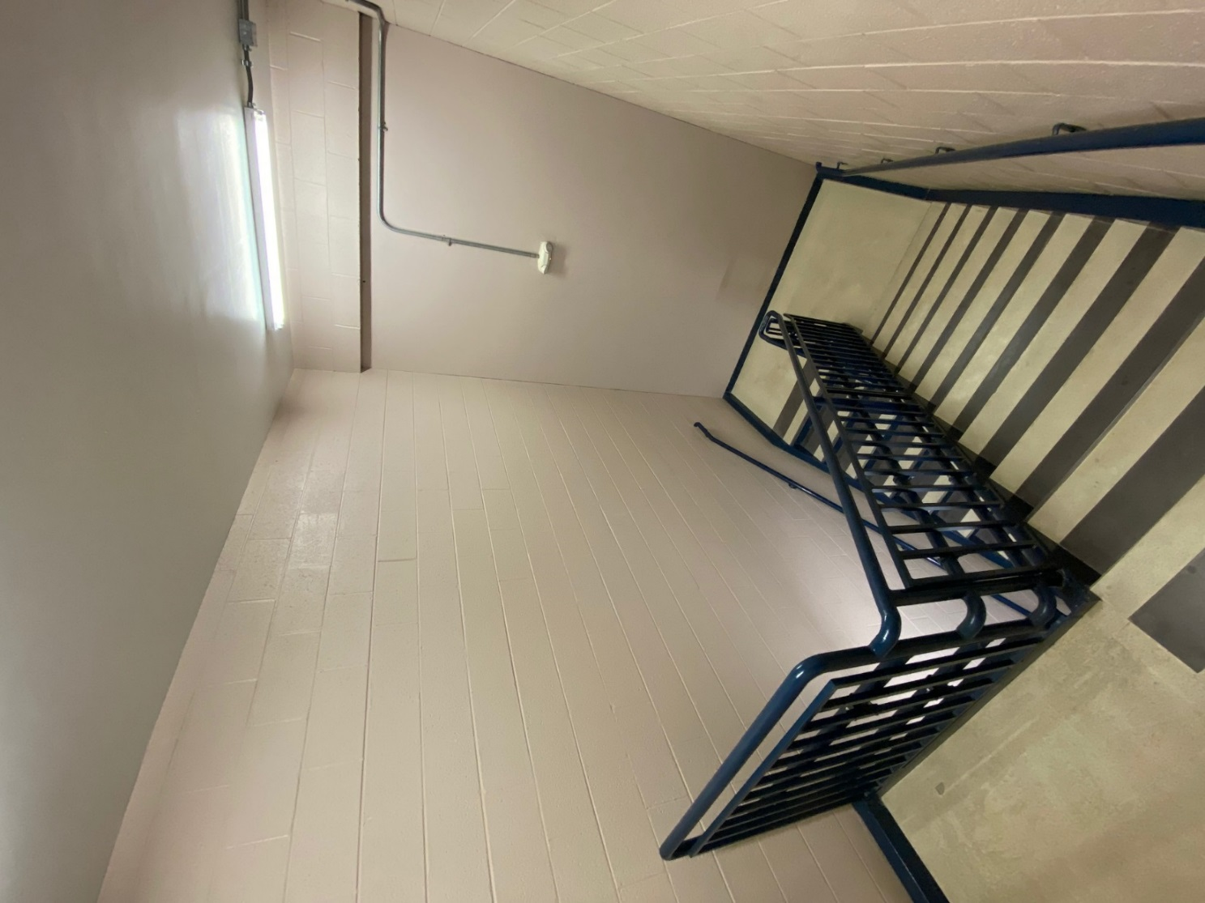

Photo 2: View of Stairwell from intermediate landing looking northeast
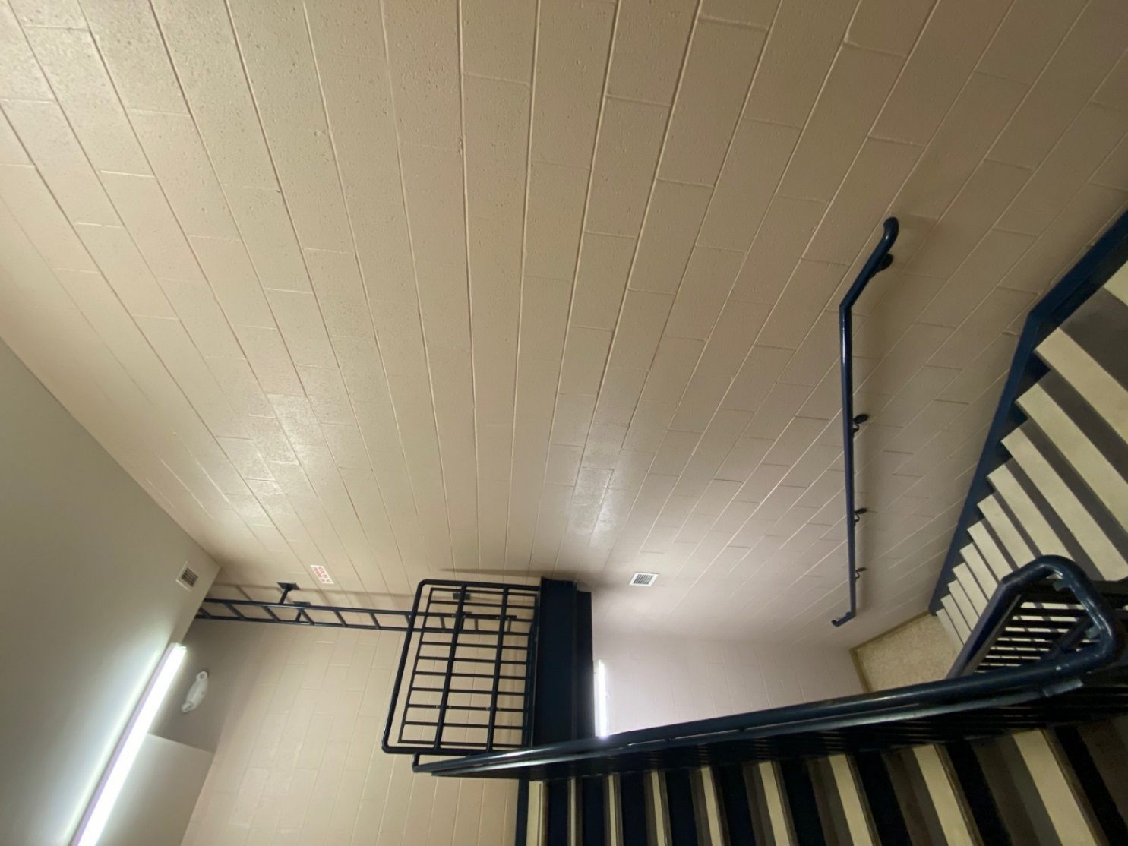

Photo 3: View of Stairwell from ground floor looking southeast.
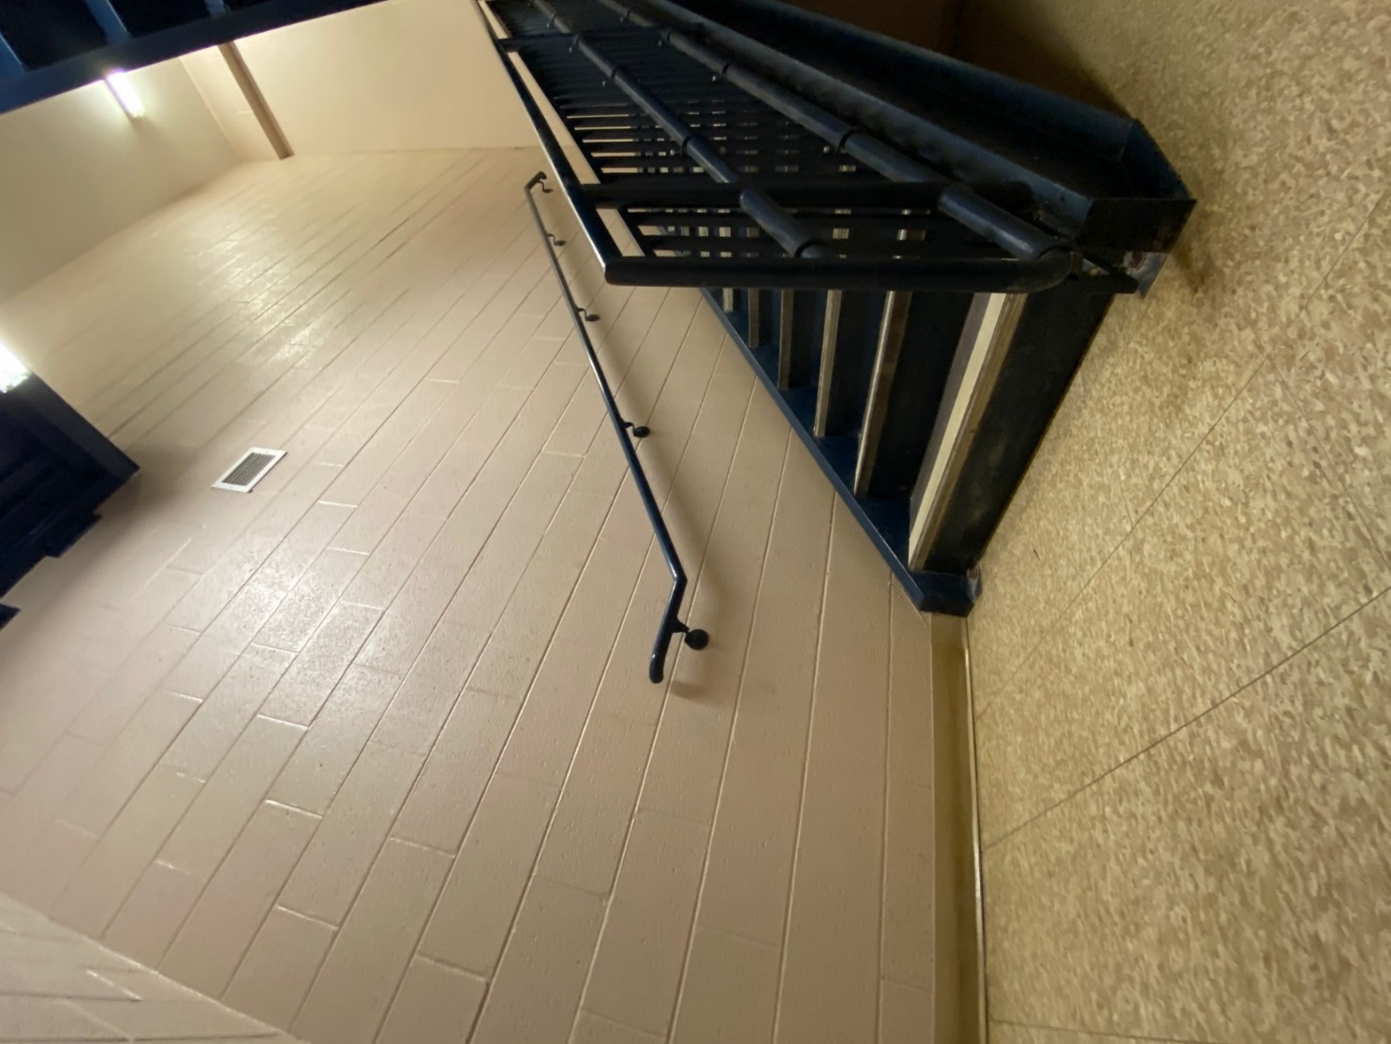

Referenced Examples:

Construction of the Dam
- Smithsonian American Art Museum; William Gropper 1938

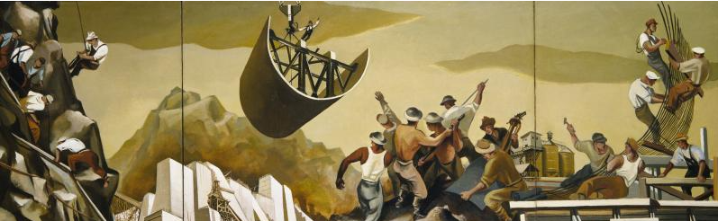

Detroit Industry Murals
- Detroit Institute of Arts; Diego Rivera; 1933

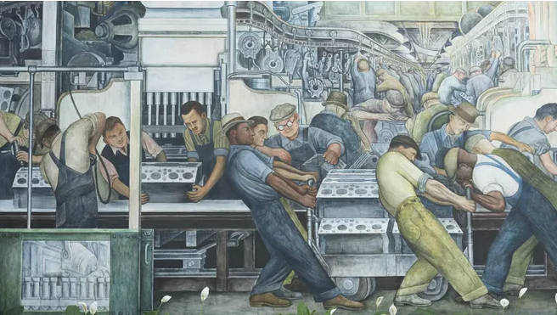
Images of the WTP and Dams:

