

Washtenaw Community College
2024 Future U Summer Camps

In 2024, Washtenaw Community College's Future U Summer camps offered an engaging exploration of STEM for students aged 5-18, focusing on coding and hands-on science experiments. These camps provided a dynamic environment where young learners were able to develop critical thinking and problem-solving skills through interactive activities. With a curriculum designed to spark curiosity and creativity, Future U empowers the next generation of innovators and tech enthusiasts.

Camp Schedule

- June 24-28, 2024 NASA Space Explorers: 20 students

- July 8-July 11, 2024 Esports: 14 students
Brixology: 16 students

- July 29-August 2, 2024 Eureka STEM Maker: 14 students
3D @ WCC: 8 students

- August 5- August 9, 2024 Underground Explorers: 21 students
Health Care Exploration: 10 students

Instructors

To staff the FutureU Summer camps, WCC partnered with MadScience and WCC faculty members. WCC faculty members were able to develop and instruct courses using classrooms and materials that were available to Washtenaw Community College students. Faculty experts were professors of advanced manufacturing, game design, 3D animation, and nursing. Madscience brought its materials, instructors and specialized curriculum, including NASA-sanctioned lessons.

Student Information

Total Spring-Summer Students Enrolled = 104

- Gender (all students)
  - 67 (64.42%) Male
  - 37 (35.58%) Female

- Total Ypsilanti students 65 (62.5% of total student enrollment)
  - 51 (78.5%) 48197 zip code
  - 14 (21.5%) 48198 zip code

- Ypsilanti Student Enrollment by Class
  - 3D @ WCC
    - Total Students enrolled= 8
    - Ypsilanti area students enrolled=5, 62.5%
    - Scholarships used = $1,495.00
  - NASA Space Explorers
    - Total Students enrolled= 21
    - Ypsilanti area students enrolled = 11, 52.38%
    - Scholarships used = $3,289.00
  - Esports
    - Total Students enrolled = 14
    - Ypsilanti area students enrolled = 6, 42.86%
    - Scholarships used = $534.00
  - Brixology
    - Total Students enrolled = 14
    - Ypsilanti area students enrolled = 6, 42.86%
    - Scholarships used = $1,794.00
  - Health Care Career Exploration
    - Total Students enrolled = 10
    - Ypsilanti area students enrolled = 6, 60%
    - Scholarships used =$1,200.00
  - Eureka STEM Maker
    - Total Students enrolled = 16
    - Ypsilanti area students enrolled = 13, 81.25%
    - Scholarships used =$3,887.00
  - Underground Explorers
    - Total Students enrolled = 21
    - Ypsilanti area students enrolled =18, 85.71%
    - Scholarships used = $5,382.00

- Total Scholarship $ Used = $17,581.00

The following images overview the full Spring-Summer 2024 Camp program and student information.
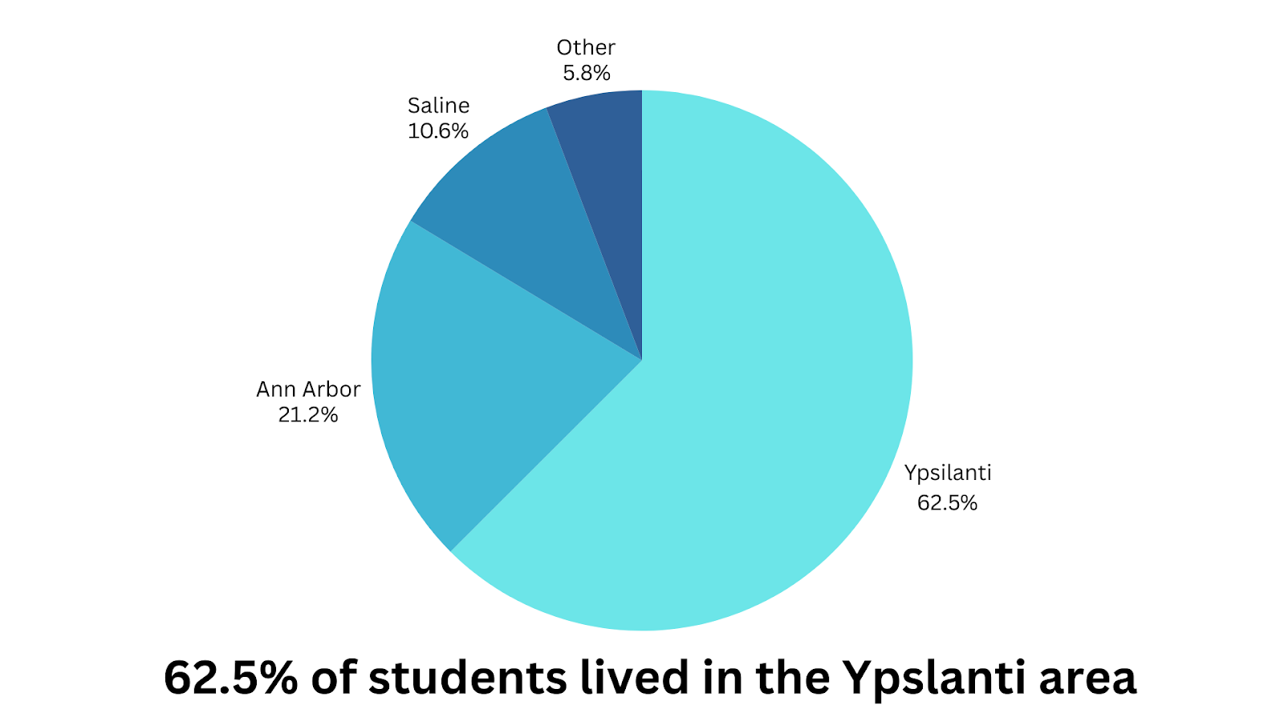

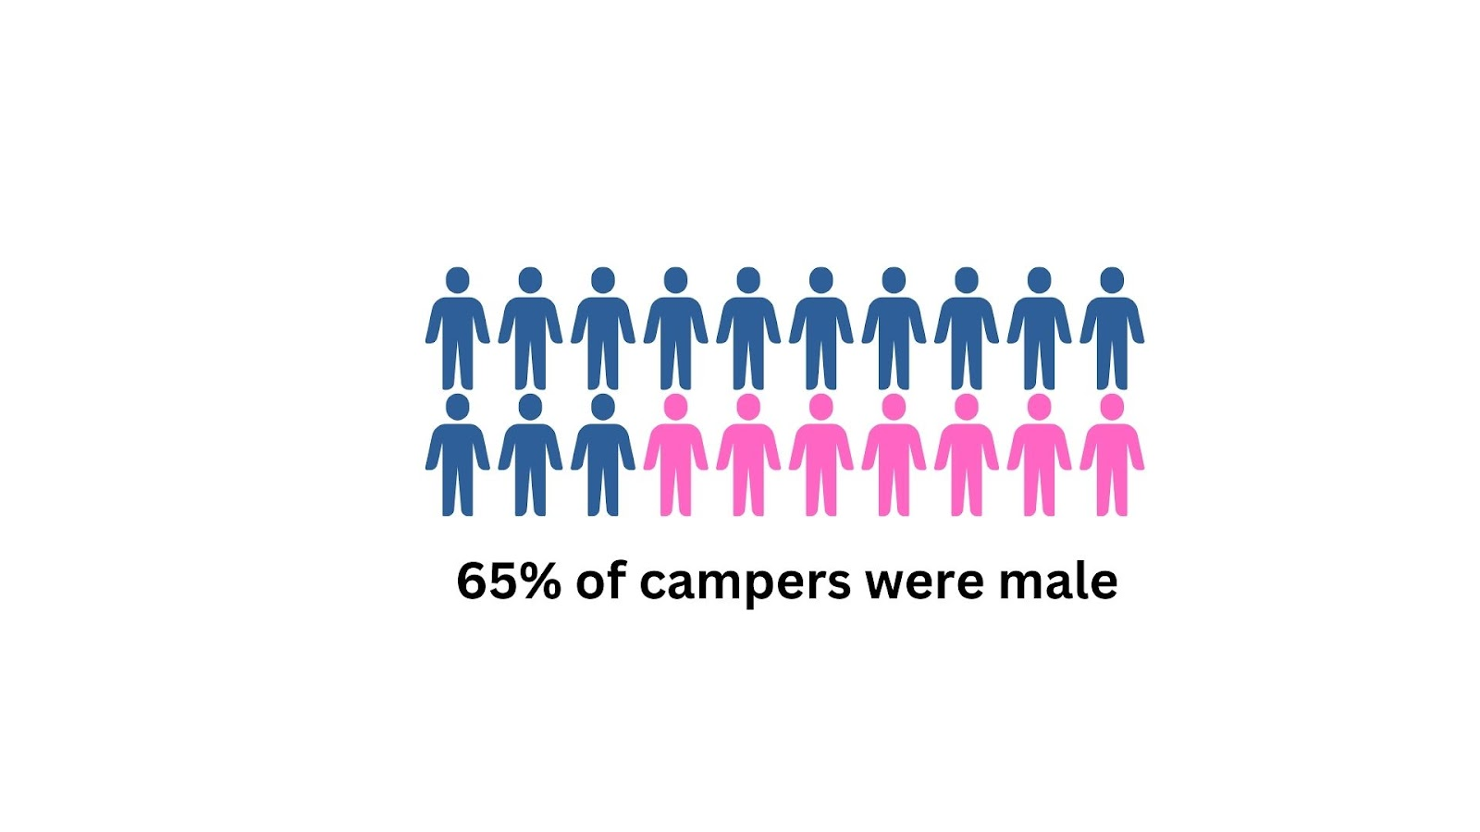
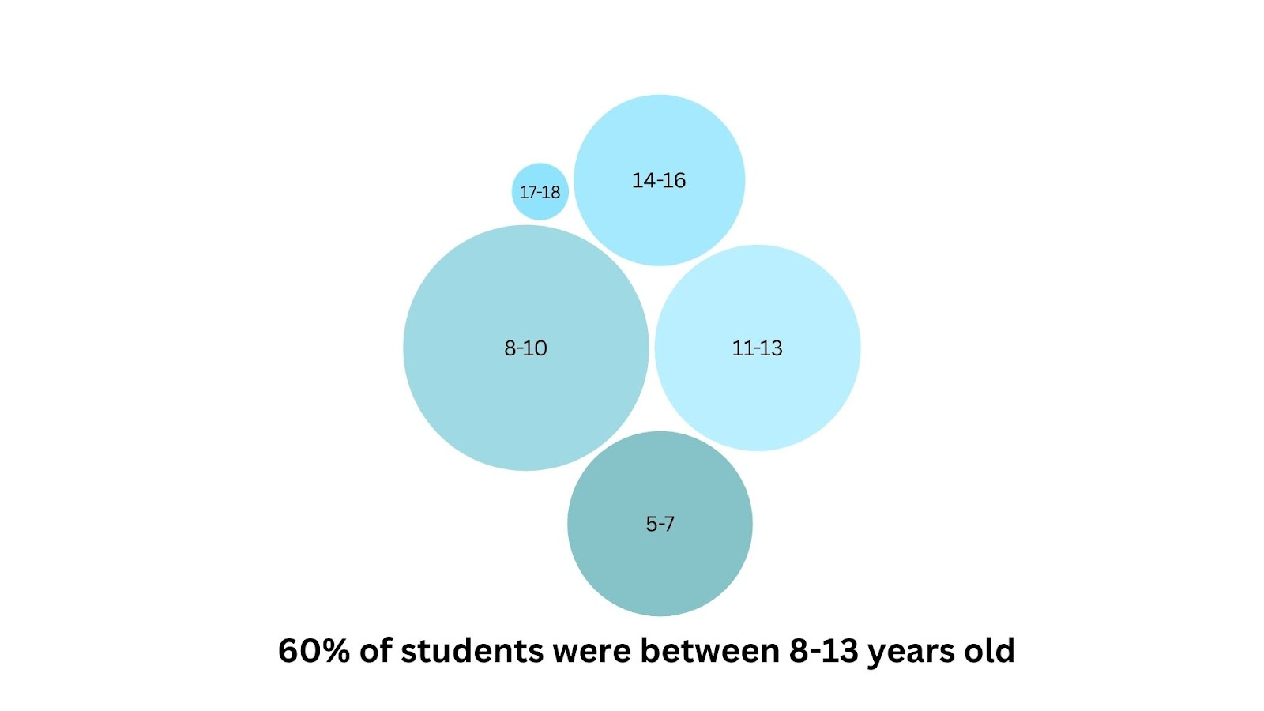

Scholarships & Camp Cost

The lowest-priced camp was $89 for a 4-day half-day camp. The average cost of a half-day camp Monday- Friday was $250.00 during the 2024 summer program. Each camp had over 40% of students attend using a scholarship awarded based upon address.

Takeaways from Summer 2024

- The 2024 Summer Semester saw the largest number of students enrolled since pre-pandemic.
- Change in leadership with the addition of Sophia McCain, part-time Program Development Manager.
- Limit the class size and age bands within classes.
- Family surveys requested full-day options.

Recommendations for Summer 2025

- Expand half-day and full-day camps for upper elementary, middle, and high school students in Washtenaw County
- Camps should take place from July 7 - August 8, 2025, and run Monday - Friday
- Host a Future U information open house on campus in April 2025, for marketing and enrollment purposes
- Hire 3-4 content masters to instruct STEAM camps
- Partner with WCC staff to implement CCAT grant-funded topics
- Expand advertising agenda with WCC partners.

