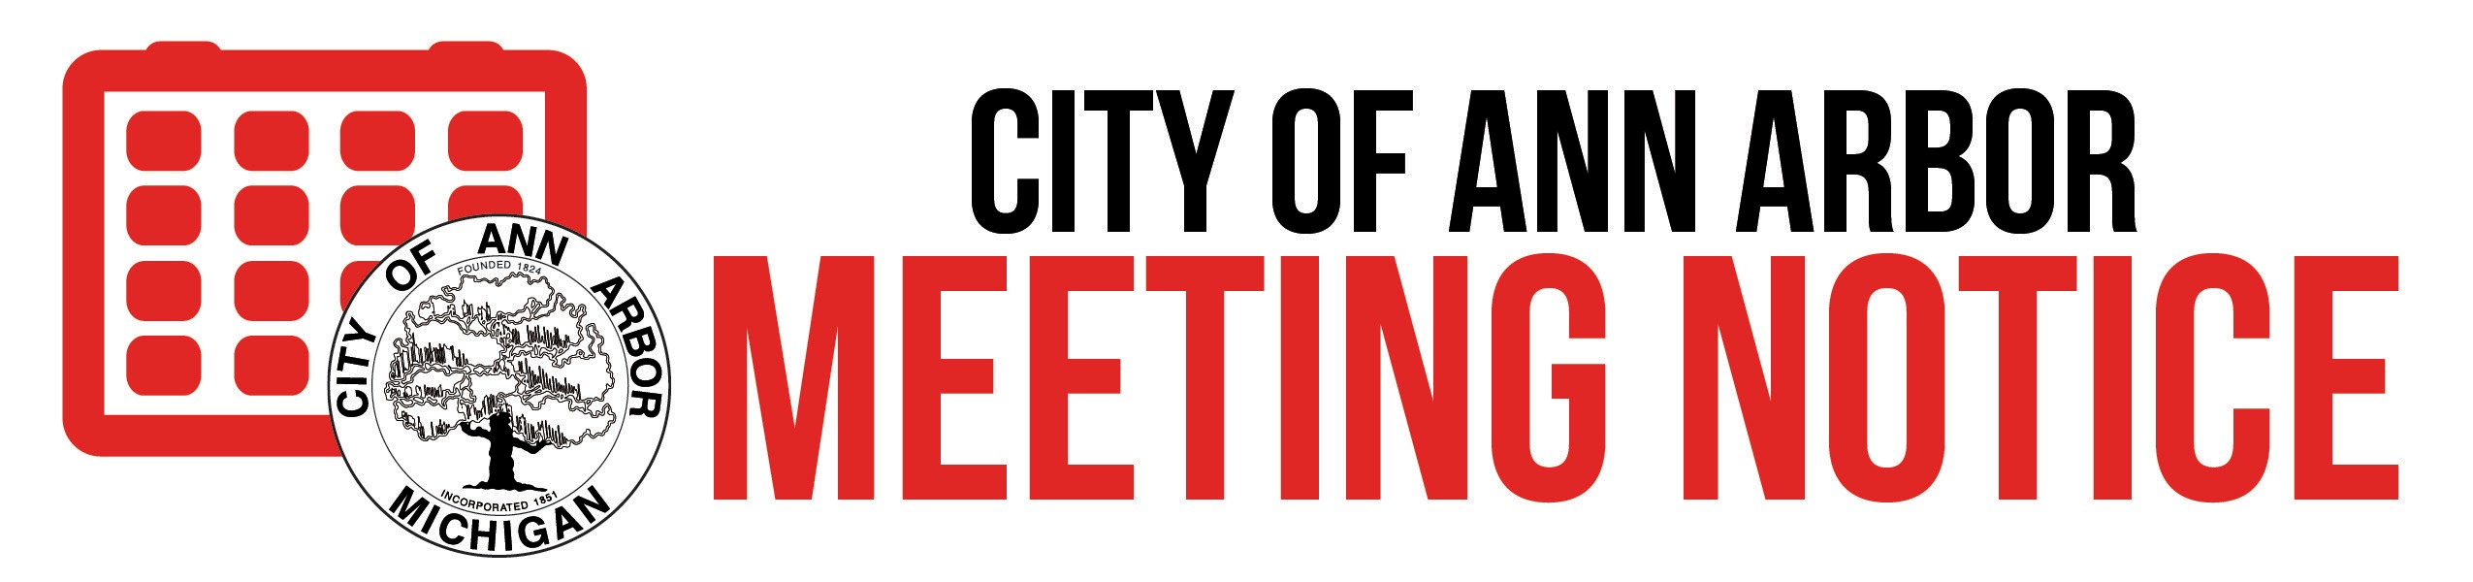

Ann Arbor Commission on Disability Issues Commission on Disability Issues Meeting Dates 2025
All meetings will be held via Zoom, unless otherwise noted at 4:00 p.m. Check the City of Ann Arbor’s homepage (www.a2gov.org) and click the link to Public Notices of Non-regularly Scheduled or Electronic Meetings. Notices of electronic meetings will be posted there no later than 18 hours prior to the meeting start. This meeting will be broadcast live on CTN Cable Channel 16, ATT Channel 99. Online at a2gov.org/watchCTN. To speak at public comment call Toll Free: 877 853 5247 or 888 788 0099 Enter Meeting ID: 919 8673 1455

January 15, 2025 | February 19, 2025 | March 19, 2025
April 16, 2025 | May 21, 2025 | June 18, 2025
NO MEETING | NO MEETING | September 17, 2025
October 15, 2025 | November 19, 2025 | December 17, 2025

Contact Person:
Kennedi Blair Cummings
(734) 794-6291
kcummings@a2gov.org
Posted:

All persons are encouraged to participate in public meetings. Accommodations, including sign language interpreters, may be arranged by contacting the City Clerk's office at 734.794.6140; via email to: cityclerk@a2gov.org; or by written request addressed and mailed or delivered to:
City Clerk's Office 301 E. Huron St. Ann Arbor, MI 48104
Requests need to be received at least 2 business days in advance of the meeting.

