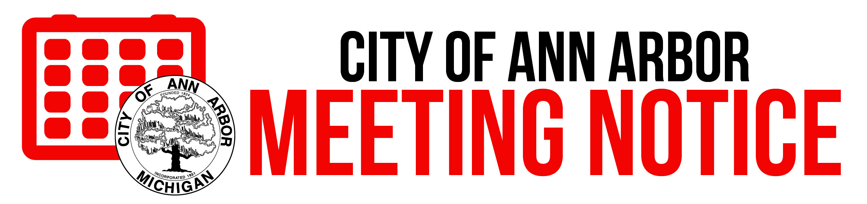
Greenbelt Advisory Commission Meeting Dates
All meetings will be held via Zoom, unless otherwise noted at 4:00PM. Check the City of Ann Arbor’s homepage (www.a2gov.org) and click the link to Public Notices of Non-regularly Scheduled or Electronic Meetings. Notices of electronic meetings will be posted there no later than 18 hours prior to the meeting start.

January 9, 2025
February 6, 2025
March 6, 2025
April 3, 2025
May 1, 2025
June 5, 2025
July 10, 2025
August 7, 2025
September 11, 2025
October 9, 2025
November 6, 2025
December 4, 2025

Rosie Pahl Donaldson
Community Services
3875 E. Huron River Dr.
734.794.6627
greenbelt@a2gov.org
Posted: 11/11/2024

All persons are encouraged to participate in public meetings. Accommodations, including sign language interpreters, may be arranged by contacting the City Clerk's office at 734.794.6140; via email to: cityclerk@a2gov.org; or by written request addressed and mailed or delivered to:
City Clerk's Office
301 E. Huron St.
Ann Arbor, MI 48104
Requests need to be received at least 2 business days in advance of the meeting.

